**Scientific and Technical Writing (BHM-201)**

**UNIT - 1**

**Communication**

The word communication is derived from a Latin word meaning “to share.” Communication can be defined as “purposefully and actively exchanging information between two or more people to convey or receive the intended meanings through a shared system of signs and (symbols)”.

**Communication process**

The communication process includes the steps we take in order to ensure we have succeeded in communicating. The communication process comprises essential and interconnected elements detailed in Fig. 1. We will continue to reflect on the story of your friend in the coffee shop to explore each element in detail.

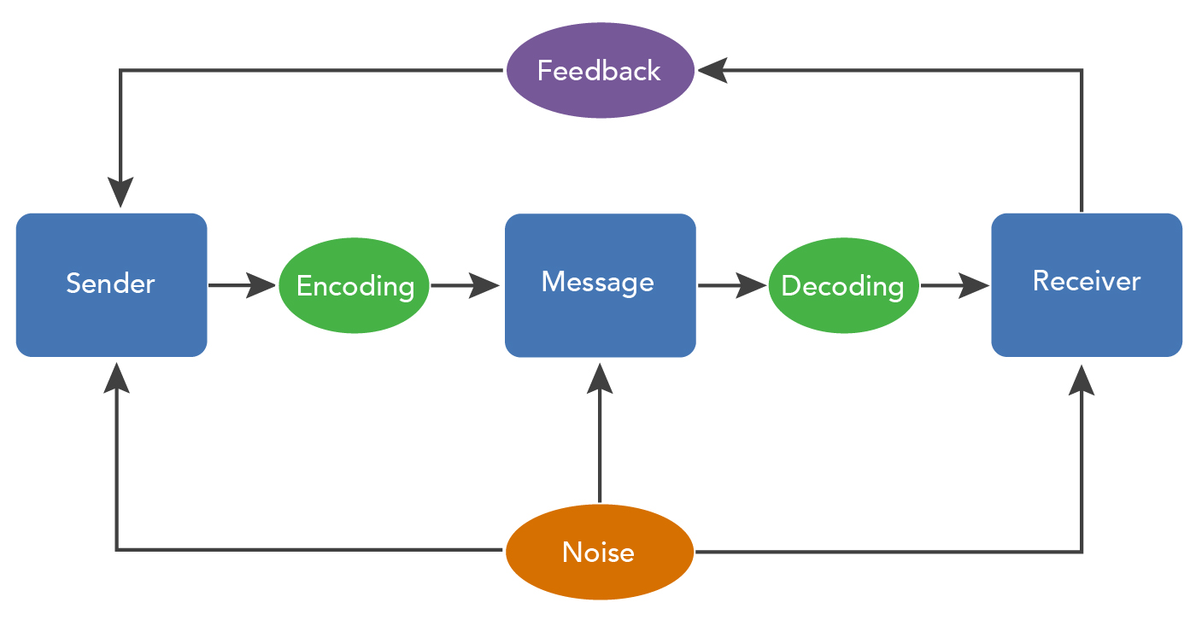

**Source**: The source comes up with an idea and sends a message in order to share information with others. The source could be one other person or a group of people. In our example above, your friend is trying to share the events leading up to their first hockey goal and, likely, the feelings they had at the time as well. Message: The message is the information or subject matter the source is intending to share. The information may be an opinion, feelings, instructions, requests, or suggestions. In our example above, your friend identified information worth sharing, maybe the size of one of the defense players on the other team, in order to help you visualize the situation.

**Channels**: The source may encode information in the form of words, images, sounds, body language, etc. There are many definitions and categories of communication channels to describe their role in the communication process. This module identifies the following **channels**: verbal, non-verbal, written, and digital. In our example above, your friends might make sounds or use body language in addition to their words to emphasize specific bits of information. For example, when describing a large defense player on the other team, they may extend their arms to explain the height or girth of the other team’s defense player.

**Receiver**: The receiver is the person for whom the message is intended. This person is charged with decoding the message in an attempt to understand the intentions of the source. In our example above, you as the receiver may understand the overall concept of your friend scoring a goal in hockey and can envision the techniques your friend used. However, there may also be some information you do not understand—such as a certain term—or perhaps your friend describes some events in a confusing order. One thing the receiver might try is to provide some kind of feedback to communicate back to the source that the communication did not achieve full understanding and that the source should try again.

**Environment**: The environment is the physical and psychological space in which the communication is happening (Mclean, 2005). It might also describe if the space is formal or informal. In our example above, it is the coffee shop you and your friend are visiting in.

**Context**: The context is the setting, scene, and psychological and psychosocial expectations of the source and the receiver(s) (McLean, 2005). This is strongly linked to expectations of those who are sending the message and those who are receiving the message. In our example above, you might expect natural pauses in your friend’s storytelling that will allow you to confirm your understanding or ask a question.

**Interference**: There are many kinds of interference (also called “noise”) that inhibit effective communication. Interference may include poor audio quality or too much sound, poor image quality, too much or too little light, attention, etc. In our working example, the coffee shop might be quite busy and thus very loud. You would have trouble hearing your friend clearly, which in turn might cause you to miss a critical word or phrase important to the story.

**A System of Symbols**

Symbols are arbitrary representations of thoughts, ideas, emotions, objects, or actions used to encode and decode meaning (Nelson & Shaw, 2002). Symbols stand for or represent, something else. For example, there is nothing inherent about calling a cat a cat.

English speakers have agreed that these symbols (words), whose components (letters) are used in a particular order each time, stand for both the actual object, as well as our interpretation of that object. This idea is illustrated by C. K. Ogden and I. A. Richard’s triangle of meaning. The word “cat” is not the actual cat. Nor does it have any direct connection to an actual cat. Instead, it is a symbolic representation of our idea of a cat, as indicated by the line going from the word “cat” to the speaker’s idea of “cat” to the actual object.

Symbols have three distinct qualities: they are arbitrary, ambiguous, and abstract. Notice that the picture of the cat on the left side of the triangle more closely represents a real cat than the word “cat.” However, we do not use pictures as language, or verbal communication. Instead, we use words to represent our ideas. This example demonstrates our agreement that the word “cat” represents or stands for a real cat and our idea of a cat. The symbols we use are **arbitrary** and have no direct relationship to the objects or ideas they represent. We generally consider communication successful when we reach agreement on the meanings of the symbols we use (Duck, 1994).

[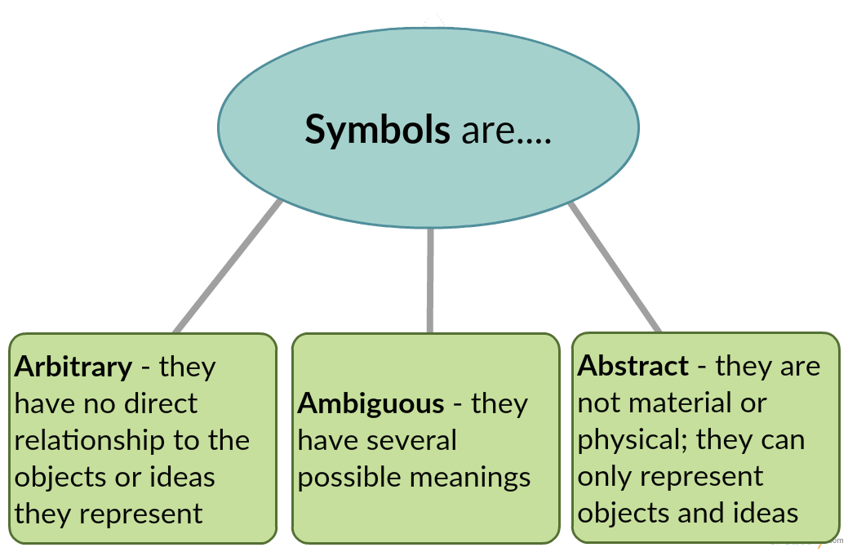](http://kell.indstate.edu/public-comm-intro/wp-content/uploads/sites/3/2016/07/symbols-are-1.png)

Not only are symbols arbitrary, they are **ambiguous** because they have several possible meanings. Imagine your friend tells you she has an apple on her desk. Is she referring to a piece of fruit or her computer? If a friend says that a person he met is cool, does he mean that person is cold or awesome? The meanings of symbols change over time due to changes in social norms, values, and advances in technology. You might be asking, “If symbols can have multiple meanings then how do we communicate and understand one another?” We are able to communicate because there are a finite number of possible meanings for our symbols, a range of meanings which the members of a given language system agree upon. Without an agreed-upon system of symbols, we could share relatively little meaning with one another.

The verbal symbols we use are also **abstract**, meaning that words are not material or physical. A certain level of abstraction is inherent in the fact that symbols can only represent objects and ideas. This abstraction allows us to use a phrase like “the public” in a broad way to mean all the people in the United States rather than having to distinguish among all the diverse groups that make up the U.S. population. Similarly, in J.K. Rowling’s Harry Potter book series, wizards and witches call the non-magical population on earth “muggles” rather than having to define all the separate cultures of muggles. Abstraction is helpful when you want to communicate complex concepts in a simple way. However, the more abstract the language, the greater potential there is for confusion.

**Types of Communication**

Verbal communication is about language, both written and spoken. In general, verbal communication refers to our use of words while nonverbal communication refers to communication that occurs through means other than words, such as body language, gestures, and silence. Both verbal and nonverbal communication can be spoken and written. Many people mistakenly assume that verbal communication refers only to spoken communication. However, you will learn that this is not the case. Let’s say you tell a friend a joke and he or she laughs in response. Is the laughter verbal or nonverbal communication? Why? As laughter is not a word we would consider this vocal act as a form of nonverbal communication. For simplification, the box below highlights the kinds of communication that fall into the various categories. You can find many definitions of verbal communication in our literature, but for this text, we define **verbal communication** as *an agreed-upon and rule-governed system of symbols used to share meaning*. Let’s examine each component of this definition in detail.

|  |  |  |
| --- | --- | --- |
|  | **Verbal Communication** | **Nonverbal Communication** |
| Oral | Spoken Language | Laughing, Crying, Coughing, etc. |
| Non-Oral | Written Language/Sign Language | Gestures, Body Language, etc. |

**Verbal Communication** is further divided into:

* Oral Communication
* Written Communication

### Oral Communication

In oral communication, Spoken words are used. It includes face-to-face conversations, speech, telephonic conversation, video, radio, television, voice over internet. In **oral communication**, communication is influence by pitch, volume, speed and clarity of speaking.

**Advantages of Oral communication** are:  
It brings quick feedback.  
In a face-to-face conversation, by reading facial expression and body language one can guess whether he/she should trust what’s being said or not.

**Disadvantage of oral communication**  
In face-to-face discussion, user is unable to deeply think about what he is delivering.

### Written Communication

In written communication, written signs or symbols are used to communicate. A written message may be printed or hand written. In written communication message can be transmitted via email, letter, report, memo etc. Message, in written communication, is influenced by the vocabulary & grammar used, writing style, precision and clarity of the language used.

**Written Communication is most common form of communication being used in business.** So, it is considered core among business skills.

Memos, reports, bulletins, job descriptions, employee manuals, and electronic mail are the types of written communication used for internal communication. For communicating with external environment in writing, electronic mail, Internet Web sites, letters, proposals, telegrams, faxes, postcards, contracts, advertisements, brochures, and news releases are used.

**Advantages of written communication** includes:  
Messages can be edited and revised many time before it is actually sent.  
Written communication provide record for every message sent and can be saved for later study.  
A written message enables receiver to fully understand it and send appropriate feedback.

**Disadvantages of written communication** includes:  
Unlike oral communication, Written communication doesn’t bring instant feedback.  
It take more time in composing a written message as compared to word-of-mouth. and number of people struggles for writing ability.

## ****Types of Verbal communication****

Words, sounds, and languages are only part of verbal communication. To communicate effectively with your audience, you must first understand who they are. Remember to use the Pyramid Principle and begin with your core argument before moving on to supporting assertions. Based on your audience, you may divide verbal communication into four categories.

#### ****Here are the Types of Verbal Communication:****

**Intrapersonal Communication :** Intrapersonal communication is communication within us. It is also called as internal communication. It includes self-thinking, analysis, thoughts, assessments, etc. associated with the inner state of mind. The person's internal thoughts or feelings play a vital role in intrapersonal communication. It also includes various activities, such as solo speaking, solo writing, solo dancing, concentration, and self-awareness.

**Interpersonal Communication:** This is also known as one-on-one verbal communication. This form of communication takes place between two people. Interpersonal communication is the communication between us and others over the channel. The communication can be online, face-to-face, video conference on mobile, etc. Interpersonal skills are essential, whether we are a manager, employee, or looking for work. Such skills are also known as soft skills that determine how well a person can communicate, behave, and relate to others.

**Small group Communication:** In small-group communication, the number of persons grows. You progress from speaking with only one person to a group of several people. Team meetings, board meetings, and sales meetings are all examples of small gatherings. The group is small enough that everyone can converse with one another. Prepare a subject for your small group sessions so you don’t get off course. Keep the discussion on track and give everyone ample time to speak.

**Public Communication:**  
This style is also known as ‘public speaking.’ An individual speaks to a huge group of individuals at the same time. Public communication includes speeches, political campaigns, and presentations, to name a few examples. Because the number of persons in the audience is bigger in this sort of communication, make sure to use easy-to-understand terms and phrases and organise your thoughts before speaking to them. You’ll feel more confidence as a public speaker if you’re well-prepared.

## ****Advantages of**** ****Verbal communication****

**Verbal communication** is said to be something which is represented through words or any other communicating medium. It is generally of two types- verbal and written communication.

**Non-Verbal Communication**

What you say is a vital part of any communication, but what you don’t say can be even more important. Research also shows that 55 percent of in-person communication comes from non-verbal cues, such as facial expressions, body stance, and smell.

According to one study, only 7 percent of a receiver’s comprehension of a message is based on the sender’s actual words; 38 percent is based on paralanguage(the tone, pace, and volume of speech), and 55 percent is based on non-verbal cues such as body language

Generally speaking, simplicity, directness, and warmth convey sincerity, and sincerity is key to effective communication. A firm handshake given with a warm, dry hand is a great way to establish trust. A weak, clammy handshake conveys a lack of trustworthiness. Gnawing one’s lip conveys uncertainty. A direct smile conveys confidence. All of this is true across North America. However, in other cultures the same firm handshake may be considered aggressive and untrustworthy. It helps to be mindful of cultural context when interpreting or using body language.

**Smell**

Smell is an often overlooked but powerful non-verbal communication method. Take the real estate agent who sprinkles cinnamon in boiling water to mimic the smell of baked goods in her homes, for example. She aims to increase her sales by using a smell to create a positive emotional response that invokes a warm, homelike atmosphere for her clients. As easy as it is for a smell to make someone feel welcome, the same smell may be a complete turnoff to someone else. Some offices and workplaces in North America ban the use of colognes, perfumes, or other fragrances to aim for a scent-free work environment (some people are allergic to such fragrances). It is important to be mindful that using a strong smell of any kind may have an uncertain effect, depending on the people, culture, and other environmental norms.

**Eye Contact**

Eye Contact In business, the style and duration of eye contact people consider appropriate varies greatly across cultures. In the United States, looking someone in the eye (for about a second) is considered a sign of trustworthiness. Facial Expressions The human face can produce thousands of different expressions. Experts have decoded these expressions as corresponding to hundreds of different emotional states. Our faces convey basic information to the outside world. Happiness is associated with an upturned mouth and slightly closed eyes; fear, with an open mouth and wide-eyed stare. Flitting (“shifty”) eyes and pursed lips convey a lack of trustworthiness. The effect facial expressions have on conversation is instantaneous. Our brains may register them as “a feeling” about someone’s character.

**Posture**

The position of our body relative to a chair or another person is another powerful silent messenger that conveys interest, aloofness, professionalism—or lack thereof. Head up, back straight (but not rigid) implies an upright character. In interview situations, experts advise mirroring an interviewer’s tendency to lean in and settle back in her seat. The subtle repetition of the other person’s posture conveys that we are listening and responding.

**Functional Communication**

Functional Communication refers to the ability to communicate one’s feelings and basic needs effectively. When children learn functional communication, they may no longer demonstrate challenging behaviours. To achieve this, we must teach communication strategies that serve the same purpose as the behaviour.

### ****Determining Function of Behaviour****

It’s important to understand the function of a child’s behaviour. A child can get upset because they don’t have a say in the snack they get or the sensory toy they get to play with. In such scenarios, we need to teach them how to express their likes and dislikes functionally.

Sometimes, children demonstrate behaviours for sensory stimulation or to seek attention. Once we understand what the child is trying to express using  behaviour, we can teach them how to address their needs using communication. Writing  down the antecedent ( what happened just before the behaviour), the behavior, and the consequence (what happened immediately after the behavior) can help understand the function of the behaviour.

### ****Using Choice Boards for Requesting****

Encouraging choice-making in children gives them a sense of control over their environment. Providing food choices during meal times or Yes/No board during activity time can help them communicate their preferences. It is important to keep in mind that the functional communication strategy taught should be easy to learn and use. Children using robust AAC systems can have vocabulary for all their favorite items programmed so that they can request the ones they like.

[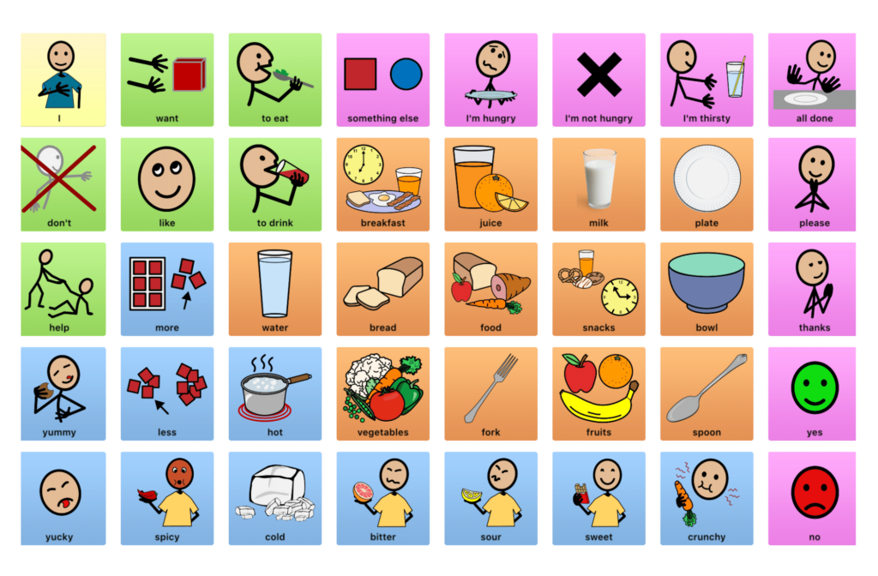](https://drive.google.com/file/d/1yYOcueN0crMJkGU-b4aOgCnznq3x4cPl/view?usp=sharing)

### ****Using Pre-stored phrases for Rejecting/Refusing****

When children do not like an activity or food, they should have a means to express that. Using pre-stored phrases such as ‘I don’t like it’, ‘I don’t want to”, or ‘Stop’ make it easier for children to refuse or reject something. We need to model refusal and use prompts in the beginning. It’s important to create consistent opportunities to practice. While encouraging them to refuse, we must remember to acknowledge and reinforce their communication whenever possible.

### ****Emotions Chart****

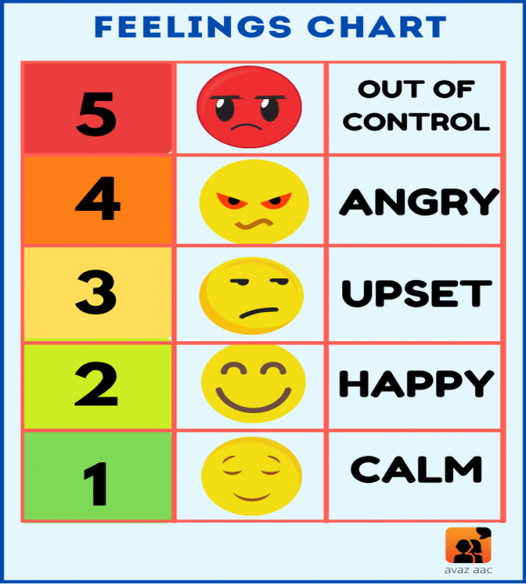

When a child gets upset or excited about something, they may demonstrate behaviours that can be considered disruptive. Teaching them to use a Feelings chart can enable them to communicate their emotions functionally. Even children with special needs who are verbal may find it difficult to access their natural speech when they are overwhelmed. Pictures can help them process and express their emotions better.

When children learn to use communication responses instead of challenging behaviours, it boosts their self-esteem. Functional communication skills also help special needs kids in their social interactions, thus improving their quality of life.

**Situational Communication**

Situational Communication is fundamentally different from Interpersonal Communication. It’s a clear, concise and focused communication and relating strategy that maximizes a minimum amount of time to achieve successful results and effective relationships. Although it’s often used in personal settings, Situational Communication is mostly reserved for business and professional interactions (especially those that are challenging, where the points of view, interests or preferred solutions of the communicators are different or in conflict). Situational Communication® is precisely the kind of communication leaders must be capable of planning for and executing in order to be both successful and effective. These interactions differ enormously from your run of the mill interpersonal interactions that are generally effortless, thoughtful engagements. Situational Communication represents thoughtful engagement – with a purpose. In this case, there’s a planned payoff. These types of interactions are more formal, structured and well planned, requiring significant energy and focus.

**LSRW**

The core Communicative skills are Listening, Speaking, Reading and Writing. To become an effective communicator, one must achieve all these four skills. These skills enrich a person in all wakes of his life. Communication is the most important factor that helps to build a better relationship with one another. In order to show case what you are and what another person is saying, you need to build a better communication. These four skills will fetch you to become a better person in different phases of one’s life.

**Listening Skills:**

Listening has been defined as a "thoughtful attention one pays to what is heard". It explains much of what Listening should be. We hear sounds and make out a meaning out of them and curate a response, quick or delayed, but for sure we respond. If the sounds don't mean anything or we don't see them as part of the 'interaction' we ignore them, refuse to react, even though we hear the sounds. Listening is the Primary Skill that makes us sensible human. It is not wrong to say that We have turned civilised because we could give 'thoughtful attention' to what was said by the thinkers and changemakers.

**Stages of Listening**

Listening involves six stages. They are;

1. Hearing/Sensing: This is the first step in the process of listening. In this stage, the listener receives certain sound wave which falls to the eardrum.

2. Recognizing/Understanding: After sensing the sounds which falls to the eardrum, the listener identifies the speech patterns. A deliberate attempt is made by the listener to comprehend the word or symbols that we hear.

3. Interpreting: In this stage the listener starts decoding the message. Listener stick on their beliefs, attitudes, values to decode the message.

4. Evaluating: After understanding what the speaker says, the listener assesses the quality of the message.

5. Responding: Here the listener reacts to the message. He/she shows his/her rejection or acceptance or understanding or confusion through non-verbal, cues.

6. Remembering/Memorizing: The final stage of listening. In this stage we retain the information for our future reference.

**Speaking Skills:**

We utter something and it gets a response. If so, it is speaking. We make sounds, in a defined or accepted language and the receiver/listener is able to pay "thoughtful attention", the activity of speaking gets done. Oral Communication is the other name of Speaking Skills or Spoken Communication. This skill makes us look smart amid a pool of people who have been listening things but do not express by their vocal chords. Oral Communication/Speaking Skills are crucial in the professional world now. The Paralanguage features of Pitch, Tone, Intonation, Accent etc play a big role in taking us to a good place in Speaking.

**Reading Skills:**

Initially, we could do the following types of reading (described by NCERT, Reading Development Cell):

1. Children perfectly identify the letter and they can read the words by connecting the letter.
2. Children/Beginners are able to read word-by-word from written or printed material.
3. Children are reading only the contents/books/pages/worksheets that are handed over to them by their class teachers or parents. Basically, they read the academic/curriculum books that are made for a subject.

Do you expect that by any of these READING processes, a reader can ever experience the JOY of READING? Of course, NOT!

Our Reading has to fluent and we must be able to GET THE MEANING of WHAT WE READ! This is possible with practice and practice can happen only when we do it. Reading is a Literacy Skills and it is indeed a wonderful possession for those who can decode a script.

**Writing Skills:**

Sir Francis Bacon said: "Reading makes a full man; Conference a ready man; and Writing an exact man."

**Reading** gives you an immense amount of Knowledge.

**Conference**/Speaking/Discussion/Interaction enable readiness in you to express your views.

**Writing**: When you put your thoughts, knowledge in Written Words, it makes you an 'exact' man/Communicator. The world knows what is documented or recorded. In this case, even the voice recording can be considered as 'written'. We post things on Social Media or we write them with a pen or pencil, all these are our WRITINGS. It is not just about handwriting which needs to be neat, it is more about the words we select in usage and the positioning of words, per se, sentence structure. Grammar plays a very important role here. Accuracy, Brevity and Clarity (of thought and expression) is vital for Impressive Writing Skills.

**Language Acquisition Through Training**

**LSRWGV**

**LSRW (Refer from above )**

**Grammer**

Communication is an integral human activity. No human can live in isolation and to live in a society, we need to interact. For interaction between two people, we need to communicate.

Oxford dictionary defines communication as activity or process used for expression of ideas and feelings or used by people for giving information. Hence we can say that it involves sharing of ideas and information between one person to other person.

When a child grows, it is necessary that he is taught how to communicate as when the children are taught how to express themselves, they develop better communication skills rather than only by imitating. It is useful for their future as they have to go in the outside world. So we can say that grammar is important due to a variety of reasons.

Grammar is a study of the rules of a language. It forms the backbone of a language and it acts as cement that puts bricks of language together. In a nutshell, it provides you the structure you need, to organize in order to coherently put your thoughts across. The knowledge of grammar enables you to speak correctly. It helps you to correct common errors that are made while speaking. Grammatical errors can easily confuse meaning. Some of the most common errors in– sentence structure subject/verb agreement tenses other basic mechanics and parts of speech.

**PARTS OF SPEECH- OVERVIEW**

Parts of Speech

1. Noun This part of a speech refers to words that are used to name, person, things, animals, places, ideas, or events. You come across nouns everywhere, in your day to day conversation. Example: Delhi, chair, lion, Sita

2. Pronoun A pronoun is a part of speech which functions as a replacement for a noun. Example: I, it, he, she, mine, his, her, we, they, theirs, and ours.

3. Adjective This part of speech is used to describe a noun or a pronoun. Adjectives can specify the quality, size, and number of nouns or pronouns. Examples: Smart, intelligent, small, new

4. Verb This is the most essential part of speech, for without a verb, a sentence would not exist. Simply put, this is a word that shows an action (physical or mental) or state of being of the subject in a sentence. Examples: eat, like, walk, sleep, run

5. Adverb Just like adjectives, adverbs are also used to describe words; they describe an adjective, verbs, and other adverbs. Examples: slowly, fast, briskly Very smart (Here very is an adverb modifying the adjective smart) Walk slowly (here it modifies a verb) Quite fast (here it modifies an adverb)

6. Preposition This part of speech refers to words that specify place and time. Examples – in, on, beside, at

7. Conjunction Conjunction is a part of speech which links words, phrases, or clauses. Examples – and, but, however

8. Interjection This part of speech refers to words which express emotions. Since interjections are commonly used to convey strong emotions, they are usually followed by an exclamation mark. Examples – Alas! Hurray! Oh!

**Vocabulary**

Vocabulary forms an integral part of the process of reading and readers’ comprehension. It refers to the words needed for communicating effectively. It implies receptive vocabulary and expressive vocabulary. Receptive vocabulary refers to the words that we hear and read while expressive vocabulary implies the words that we speak and write. It is rightly said that without vocabulary, it is not possible to convey anything. A broader idea of vocabulary is discussed below.

### Vocabulary Definition

Vocabulary is denoted as “the group and collection of words that are known and used by a particular person”. It can also be defined as “a list or collection of words or phrases that are normally alphabetically arranged and defined or explained”.

Vocabulary is also commonly called wordstock, lexis, and lexicon.

### Importance of Vocabulary

Vocabulary is an essential part of anyone’s life and the following points describe the importance of vocabulary.

1. Vocabulary is critical for communication and expression
2. Vocabulary forms the basis of reading comprehension
3. Linguistic vocabulary and thinking vocabulary work parallel
4. Vocabulary also forms a basis for judgment many times
5. For conveying anything, vocabulary is important

### What is Vocabulary in English?

The answer to 'what is vocabulary in English?' is all the words that form a language to be understood by a specific person or maybe a group of people. Vocabulary in English can be categorized into two types, namely- active and passive. The words that we use and understand in day-to-day language are termed as active vocabulary while the ones which we know but use rarely are said to be passive vocabulary.

### Three Tiers of Vocabulary

Vocabulary is described with the following three tiers:

1. **Basic Vocabulary**

The basic words form the first tier of vocabulary. These words normally have a single meaning and do not require instruction. Early reading words, sight words, adjectives, verbs, nouns, etc are portrayed in this tier. 8000-word families in English comprise this tier.

1. **High-frequency Vocabulary**

Also called the multiple meaning vocabulary tier, this tier comprises words used in a variety of domains, adult communication, literature, etc. It influences reading and speaking. 7000-word families comprise this tier. The characteristics for tier two words are as follows:

* It has multiple meanings
* Vital for reading comprehension
* Typical mature language
* Descriptive vocabulary
* A diverse environment use these words
* Used for direct instruction

1. **Low-frequency Vocabulary**

The words that are used only when specifically required or in a particular domain like weather, technology, geographical region, occupation, hobbies, school, etc. comprise this tier. About four lakh words in vocabulary in English comprise this tier.

### Types of Vocabulary

The types of vocabulary can be categorized based on spoken and written vocabulary. Children start vocabulary-building through listening and speaking even before writing and reading. Every type of vocabulary has a different aim and purpose. However, the development of one type of vocabulary facilitates another.

The types of vocabulary are discussed below briefly.

1. **Listening Vocabulary**

Listening vocabulary comprises words that we understand through hearing. A fetus may start recognizing some words when in the womb. Learning new words is a continuous process, and by the time you reach adulthood, almost fifty thousand words are understood and recognized by you. Deaf people can be exposed to visual listening vocabulary for learning.

1. **Speaking Vocabulary**

Speaking vocabulary consists of words that we actually speak. It has a horizon of around 5000 to 10000 words. These are used for giving instructions and conversations. The number of words in this category are comparatively lesser than the listening vocabulary.

1. **Reading Vocabulary**

The major ingredient of vocabulary building is reading. Reading grows and develops your vocabulary. The words we get to learn while reading a text are termed as reading vocabulary. It may happen that we understand words through reading vocabulary even if we don’t use it in speaking vocabulary.

1. **Writing Vocabulary**

Words we recoup while expressing ourselves through writing are termed as writing vocabulary. Writing vocabulary is normally influenced by the words we are able to spell. We find it easy to express verbally, through facial expression, or intonation, but writing vocabulary depends upon our expertise in vocabulary.

1. **Final Vocabulary**

Richard Rorty discovered this term ‘Final Vocabulary’. It is a collection, set, or group of words that every person applies to justify their actions, beliefs, and lives. Final vocabulary comprises words a person avails to praise, contempt, express deep feelings, hopes, doubts, etc.

**Presentation**

Presentation is the practice of showing and explaining the content of a topic to an audience or . Presentations come in nearly as many forms as there are life situations. In the business world, there are sales presentations, informational and motivational presentations, first encounters, interviews, briefings, status reports, image-building, and training sessions. Presentations skills and public speaking skills are very useful in many aspects of work and life. Developing the confidence and capability to give good presentations, and to stand up in front of an audience and speak well, are also extremely helpful competencies for self-development too. Presentations and public speaking skills are not limited to certain special people – anyone can give a good presentation, or perform public speaking to a professional and impressive standard.

Elements of a good talk Content Presentation Delivery

Clarity = Simplicity + Consistency

Clarity means making your content easy to understand. If people can’t understand what you’re trying to say, then your content is not useful.

The speaker should deliver the speech in simple words and sentences. Simple words and sentences make the speech effective. The best visuals are often ones designed with an eye toward simplicity. Yet this says nothing about the specifics of a visual presentation. That will depend on the content and context. For example, even the best visuals used in support of a presentation for one audience on, say, quantum mechanics may appear complicated and confusing to a different audience. Simplicity is often used as a means to greater clarity. However, simplicity can also be viewed as a consequence of our careful efforts to craft a story and create supporting visuals that focus on our audience’s needs in a clear and meaningful way.

[2](https://images.slideplayer.com/13/4025996/slides/slide_2.jpg) Explain why the audience should pay attention Make your explanation appropriate to the audience Tell the simplest possible story Show them the data early Don’t overstate results Elements of a good talk Content

[3](https://images.slideplayer.com/13/4025996/slides/slide_3.jpg) Stupid mistakes not to make Content: Overlong/over-general introductions Too much content Convoluted description of experiment/results If a data slide is difficult, build up to it gradually.

[4](https://images.slideplayer.com/13/4025996/slides/slide_4.jpg) The effect of Donezepil on visual attention

[9](https://images.slideplayer.com/13/4025996/slides/slide_9.jpg) 1 slide a minute Organizational slides? Too many words, too small font Avoid unnecessary clutter/animation Label everything Be consistent in labeling Keep structure consistent Say thank you (Choose a style and stick to it) Elements of a good talk Presentation

[10](https://images.slideplayer.com/13/4025996/slides/slide_10.jpg) Stupid mistakes not to make Presentation: Careless typos Too many words, too small font Too much animation Meaningless/confusing/inconsistent color Inconsistent terminology Failure to label axes, lines etc.

[11](https://images.slideplayer.com/13/4025996/slides/slide_11.jpg) Learn your first sentences by heart Just say it, and only once Speak slowly, with pauses between sentences Use consistent terminology For every graph explain x- y- axis and what each object in the graph represents Don’t talk about something different from what’s on the slide Sound somewhat enthusiastic Don’t be overly casual Lose your ticks/querks, “ums” (Practice in front of a mirror & wear a white shirt) Elements of a good talk Delivery

[12](https://images.slideplayer.com/13/4025996/slides/slide_12.jpg) Stupid mistakes not to make Delivery: Bad timing resulting in rushing/skipping. Adding stuff to talks at last minute is a terrible idea

[13](https://images.slideplayer.com/13/4025996/slides/slide_13.jpg) On the day Arrive early and introduce yourself to the moderator & projectionist. Tell the moderator how you want to be introduced Be assertive about your place in the set- up queue. Check all your movies/slides. Think about where you want to stand. Make sure they put the mike on the lapel towards the slides

**Professional writing**

Professional writing is a style of writing that is clear, concise, and seeks to convey information and ideas quickly in a professional setting. Professional writing is geared towards informing or persuading an audience in the world of work and commerce. A professional writing style is used because it communicates need-to-know information quickly. Professionals expect to receive the information they need right away. Time is of the essence and professional communications are often read quickly, or even skimmed, rather than read in depth. This type of writing is expected when applying for a job; when giving presentations at work; and when communicating with colleagues via email, to name a few situations. Professional writing is a complex process that involves different skills for planning, drafting and editing. Great writers must be able to quickly learn new concepts and translate ideas into original content.

**creative writing**

creative writing is a form of writing that goes beyond the traditional realms of normal, professional, academic or technical forms of writing.

Instead, it encompasses a number of different genres and styles across a whole range of fields of both fictional and non-fiction writing; storytelling, playwriting, poetry, prose, journalistic, and more.

Though the definition can be quite vague, creative writing can, for the most part, be considered as any type of writing that is original and expressive of oneself. Typically, it can be identified by an emphasis on narrative craft, focusing on elements such as character development, narrative and plot, infusing its structure with imagination, invention and story.

In this sense, creative writing can technically be considered any writing of contemporary, original composition - it's bound by no standard conventions and uses a whole range of elements in its craft.

In an academic setting, creative writing is typically divided into fiction, poetry, or scriptwriting classes, with a focus on writing in an original style, not defined by pre-existing structures and genres.

**What are the different types of creative writing?**

Creative writing comes in many forms, encompassing a number of genres and styles. There are lots of different types of creative writing, which can be categorised as fiction or non-fiction. Some of the most popular being:

* Biographies
* Fiction: novels, novellas, short stories, etc.
* Speeches
* Poetry and spoken word
* Playwriting/scriptwriting
* Personal essays
* Speeches

**What are some techniques used in creative writing?**

To make their writing stand out, writers often employ several creative writing techniques and literary devices, including:

* **Character development** - The process of creating a well-rounded, realistic character with depth, personality, and clear goals or motivations.
* **Plot development** - The story of your piece of writing - how it develops, unfolds, and moves along in time.
* **Point of view **- The perspective from which a narrative is told. It indicates who is telling the story and how the information is conveyed to the reader. Quite often writers will play with the point of view of the central character or protagonist to trick the reader and twist their perspective.
* **Dialogue** - Refers to the speech and conversations characters use to speak to one another. Dialogue and the language choices a character makes can be pivotal in helping define their personality.
* **Literary devices** - Such as metaphors, similes and alliteration to make creative writing more imaginative and descriptive. These are used in a myriad of ways by writers to make their writing more vivid, interesting and engaging.